**SaaS AI Platform**

1. Setup project by following shadcn/ui

npx create-next-app@latest ai-saas --typescript --tailwind –esl

Would you like to use ESLint? ... No / Yes (Yes)

√ Would you like to use `src/` directory? ... No / Yes (No)

√ Would you like to use App Router? (recommended) ... No / Yes (Yes)

√ Would you like to customize the default import alias (@/*)? ... No / Yes (No)

1. Run this to install shasd cn

npx shadcn@latest init

1. Modify global.css add the following code snippet
2. html,
3. body,
4. :root{
5. height: 100%;
6. }

4. Removed page .tsx form app folder and create our new named (landing) and create new page.tsx inside (landing)

5. we are Nextjs route for you have to protect our route within parenthesis refer the below image

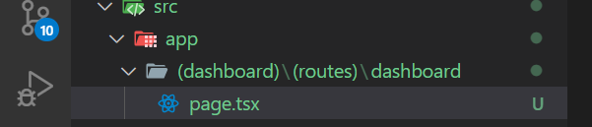

Every routes should be created like this

6. let’s add authentication first in our SaaS application for auth we will use Clerk Authentication

7. Visit clerk page application name and copy API keys in your .env file

8. Install clerk npm install @clerk/nextjs

9. Now add clerk provider to layout.tsx page and wrap your application within this see example

import { ClerkProvider } from "@clerk/nextjs";

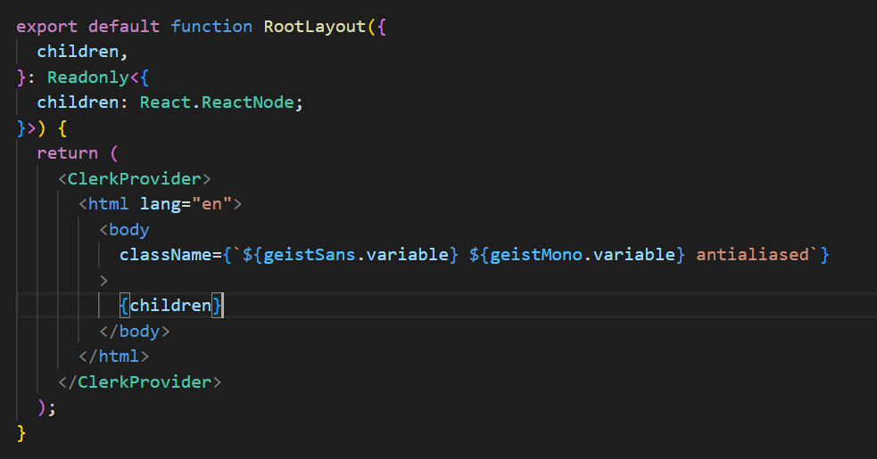

1. Now add middleware file to your root application

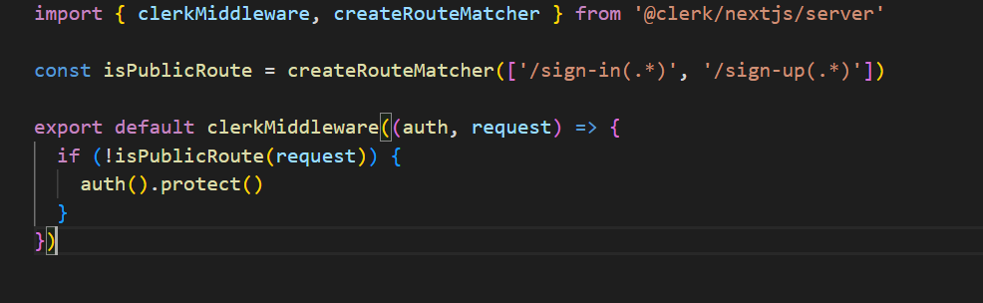

1. Now app router group for auth (auth)/(routes)/sign-up/[[…sign-up]]/page.tsx

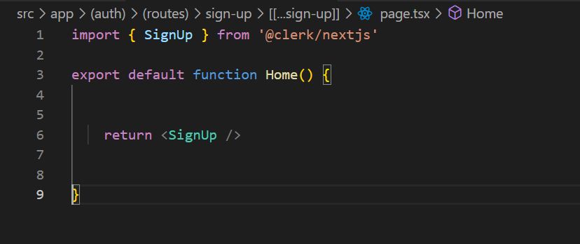

1. Similarly for sign Now app router group for auth (auth)/(routes)/sign-in/[[…sign-in]]/page.tsx

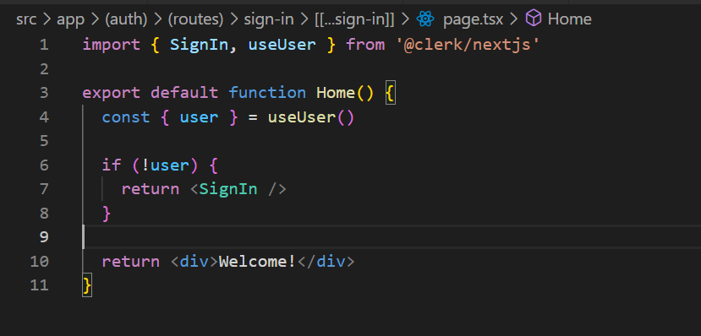

1. Now update the environment variable
2. NEXT_PUBLIC_CLERK_SIGN_IN_URL=/sign-in
3. NEXT_PUBLIC_CLERK_SIGN_UP_URL=/sign-up
4. NEXT_PUBLIC_CLERK_AFTER_SIGN_IN_URL=/dashboard
5. NEXT_PUBLIC_CLERK_AFTER_SIGN_UP_URL=/dashboard

14. Now add new page indside auth folder named as layout.tsx

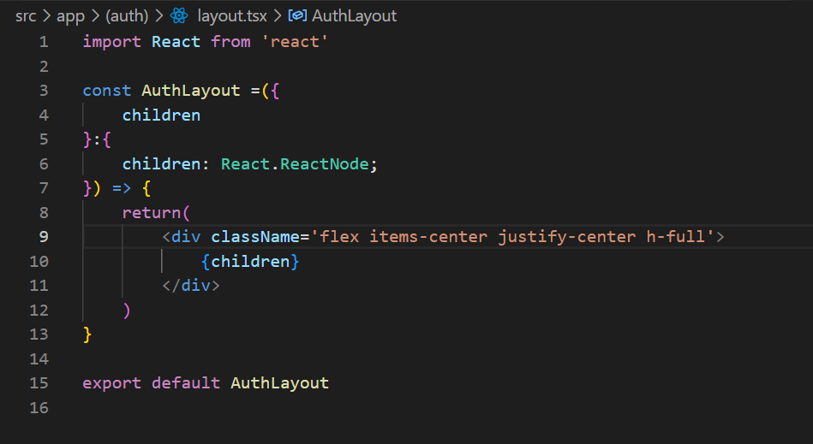

15. Now add design landing page

16. Add new layout page inside dashboard folder and design it

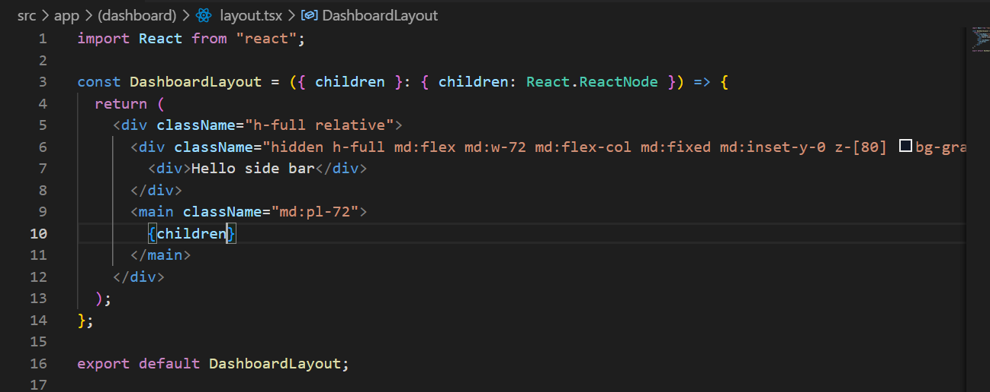

17. Add new file called navbar.tsx inside components folder and add it into dashboard layout file

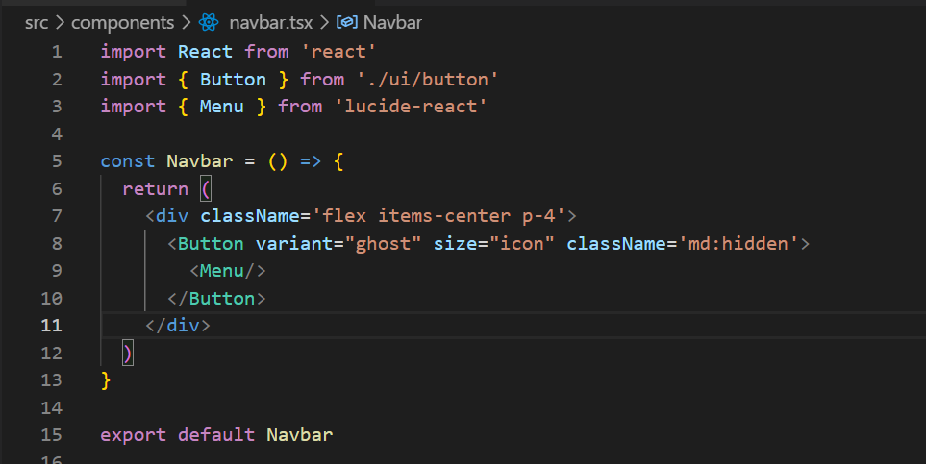

18. Now crea new component called sidebar.tsx and add into dashboard layout file and design it

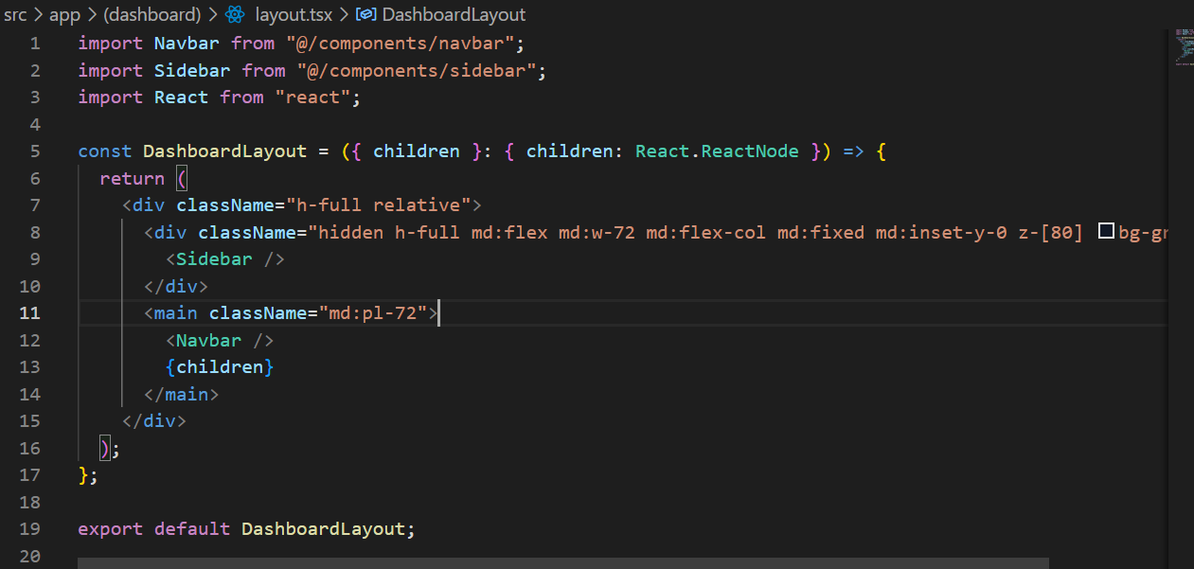

1. Add new file inside component folder called as mobile-sidebar and import inside navbar.tsx

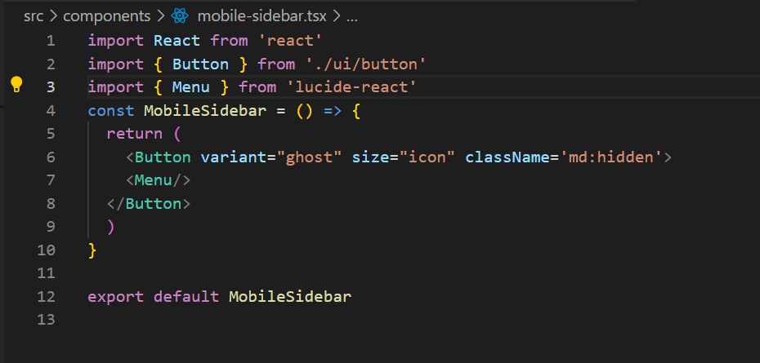

1. Insatll npx shadcn@latest add sheet and design mobile-sidebar
2. Designed the Dashboard page

